MTP Deployment Procedures for WCS, WESB, CTO/VM and OMS:

During MTP, Please Follow the below steps:

1. Model Copy job disable & HP folder Removal (Patches get deleted after deployment)
2. DB Backup
3. EAR Backup
4. Pre-Deployment activities (if any)
5. Maintenance page Enable (If approval)
6. Deployment (WCS, WESB, OMS, CTO/VM)
7. Maintenance page Disable (If approval)
8. Post- (if any)
9. Hotfix Patches Deployment activities (if any)
10. QA signoff

Step 1: Model copy job disable & HP Folder Removal:

Do remove the HP folder before start of Deployment

HP folder location:

**Stager**:/opt/apps/IBM/WebSphere/AppServer/profiles/ETRSTAGE/installedApps/WC_ETRSTAGE_cell/WC_ETRSTAGE.ear/Stores.war/WEB-INF/classes/com

**Live**:/opt/apps/IBM/WebSphere/AppServer/profiles/ETRLIVE/installedApps/WC_ETRLIVE_cell/WC_ETRLIVE.ear/Stores.war/WEB-INF/classes/com

#################################################################################################

Step 2: DB Backup:

Need to back up the DB for the respective deployment (WCS, WESB, CTO/VM and OMS)

**For Stager:**

Send this below DB details to GDBA team (*for respective deployments*):

* WCSEPC, CAEPROP, VMEPROP

Note*: Kindly request to exclude “BUSAUDIT” table

**For Live:**

Send this below DB details to GDBA team (*for respective deployments*):

* WCSPC, WESBPC, SSFPC, CAPROP

Note*: Kindly request to exclude “BUSAUDIT” table

#################################################################################################

Step 3: EAR Backup:

Need to take EAR backup for the respective deployment (WCS, WESB, CTO/VM and OMS)

Note: While taking backup please have build package name in the backup file name as naming convention for both DB & File system backups.

**Location:** /opt/apps/

**Backup folder:** IBM

**Sample file name for WCS:** IBM_wcs_t_r46526_08Feb2015_R3.2.0_223.tar.gz

**Sample Create backup:**

nohup tar --ignore-failed-read -czvf test.tar.gz test &

**Sample Restore backup:**

nohup tar --ignore-failed-read -xzvf test.tar.gz test &

Step 4: Pre-Deployment activities (if any):

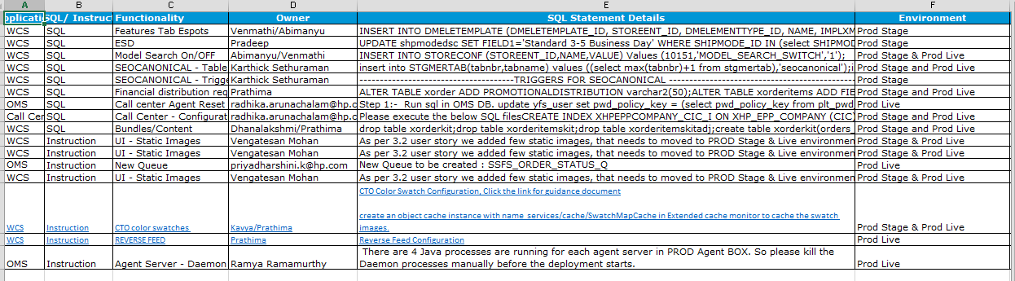

Above is the example of pre-deployment steps like SQL, Certificate Update, Instructions (Please do those before start of deployments)

#################################################################################################

Step 5: Maintenance page Enable:

Whenever there is an APAR installation / Client (or Leadership) approval, please enable the Maintenance Page for **both Estore & Mstore** , when start of Deployment.

Procedure:

Go to Akamai link: <https://control.akamai.com>

Navigate to 🡪 Configure-> cloudletsPolicyManger-> Activate Policies

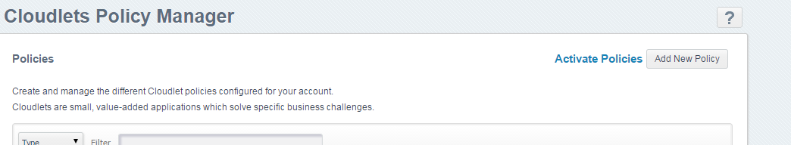

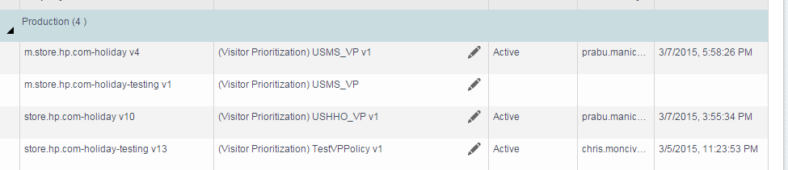

Here, you see the store.hp.com-holiday v10 (**Estore)** & m.store.hp.com-holiday v4 (**mstore**)

**Estore:**

Click the Edit on **store.hp.com-holiday v10** -> change the value to **11(Eleven)**

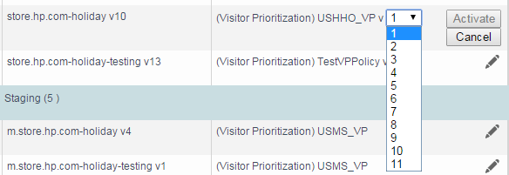

**mstore:**

Click the Edit on **m.store.hp.com-holiday v4** -> change the value to **2(Two)**

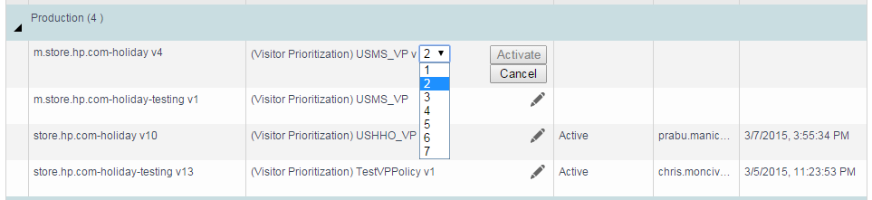

Once you done the above said, the maintenance page will enable (like below)

Estore:

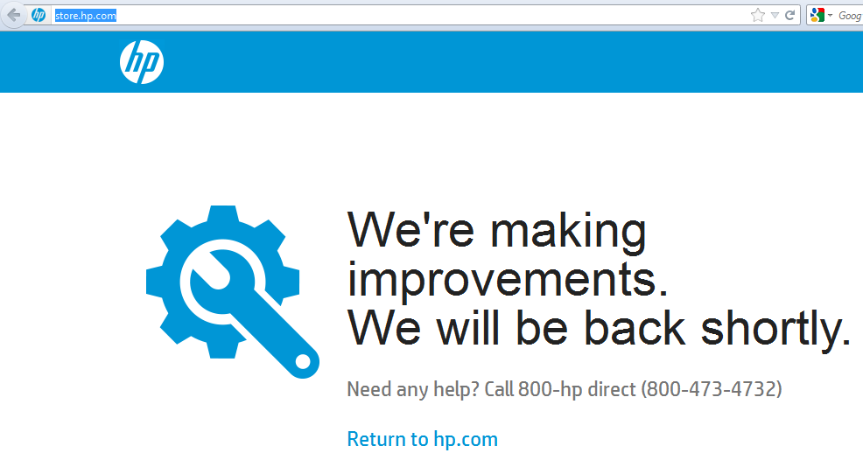

Mstore:

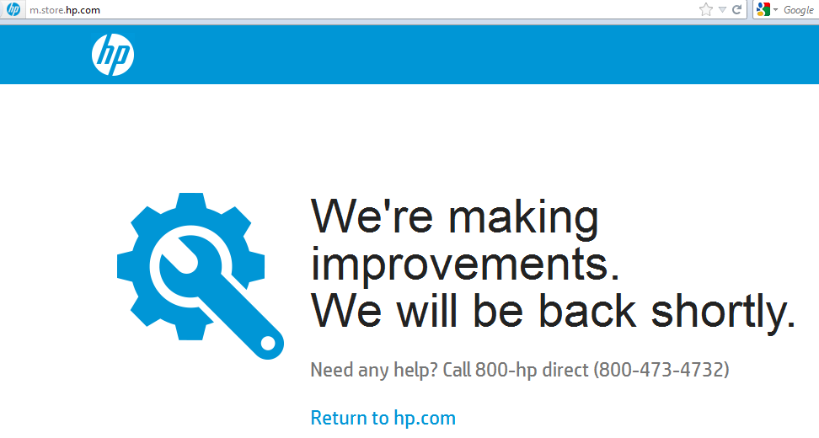

#################################################################################################

Step 6: Deployment: (Examples given for Prod Environment)

1. WCS:

Build Packages given in Release notes:

|  |  |  |  |  |  |
| --- | --- | --- | --- | --- | --- |
| **Application** | **Build Number** | **APAR** | **Query** | **Pre Deployment Instructions** | **Post Deployment Instructions** |
| WCS (Estore) | wcs_t_r46090_02Feb2015_R3.2.0_218 | **✓** | **✓** | **✓** | **✓** |
| WCS (Mstore) | wcs_t_r46090_02Feb2015_R3.2.0_218 | **×** | **×** | **×** | **×** |
| DLP | wcs_t_r46090_02Feb2015_R3.2.0_218 | **×** | **✓** | **×** | **×** |
| WESB | wesb_t_r45534_27Jan2015_code3.0_5.ear | **×** | **×** | **×** | **✓** |
| TIBCO | TIBCO_ETR3.2.0_01272015 | **×** | **×** | **×** | **×** |
| OMS and Call Center | OMS_SIT3_r45955_02FEB2015_RTRUNK_691 CDT: HP-ETR3.2.0-CDT-31-JAN-2015.zip | **×** | **×** | **✓** | **✓** |
| CTO Configurator | Configurator_t_r46066_02Feb2015_code3.0 | **×** | **×** | **×** | **×** |
| CTO Visual Modeler | Build / tag is not required since we have not done any changes on VM | **×** | **×** | **×** | **×** |

WCS Backup server: <http://c0004134.itcs.hp.com:8080/wcs>

Give Ctrl+F 🡪 give a build number and please verify once the build is available in backup server. If it is not available, please check with Leads. Once available, Start deployment

Jenkins: <http://c0006107.itcs.hp.com:8080/jenkins/>

1. Set Build Number

2. Deploy in Respective Environment

1. Set Build Number:

Click Set build number in Jenkins

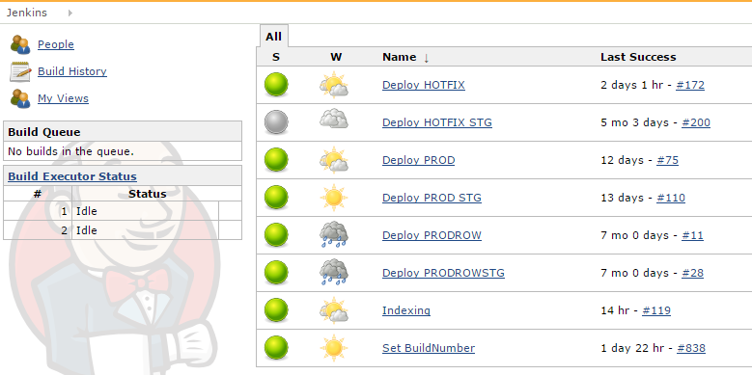

Click Build with Parameters

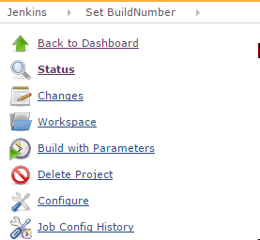

Paste the Build Number and click Build

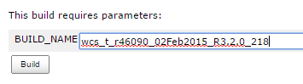

Click on Console output to view status of Set Build number:

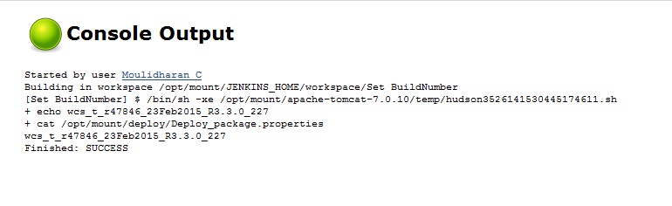

2. Deploy in Respective Environment

Once the Set Build Number is Success, Please choose the environment to deploy (for Ex: Prod Live)

Click on the Deploy Prod (for Prod Live)

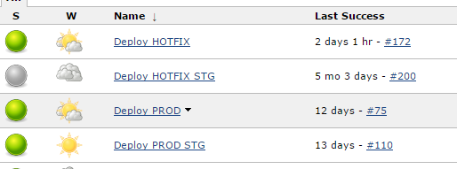

Click Configure:

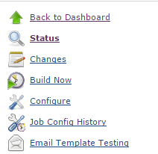

Where you can see the Execute shell box:

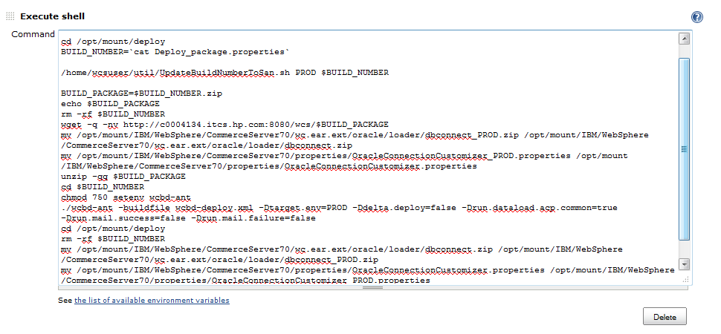

Need to check for few things here:

* Wget , remove (rm), Move (mv) commands **should not Commented**
* After **–Dtarget -> the environment name mentioned should be (the Environment where you are going to Deploy- eg: env=Prod)**
* **After checking give Build Now 🡪 Console Output to view the deploying status.**

#################################################################################################

1. WESB:

WESB is only for Live Environment

Follow the same steps (said above for WCS) to deploy WESB

**Backup Server**: <http://c0004134.itcs.hp.com:8080/wesb>

**Jenkins**: <http://c0004975.itcs.hp.com:8080/jenkins>

Set Build Number

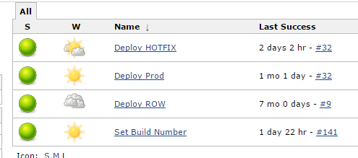

Place a WESB Build package name (.ear) and give Build. View Console Output for the completion status

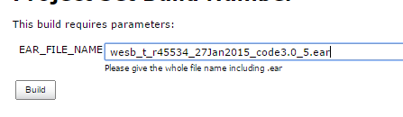

Deploy in Respective Environment

Once the Set Build Number is Success, Please choose the environment to deploy

Click on the Deploy Prod (for Prod Live) and click configure (It looks likes below – Target ghost is 4190 wesb box)

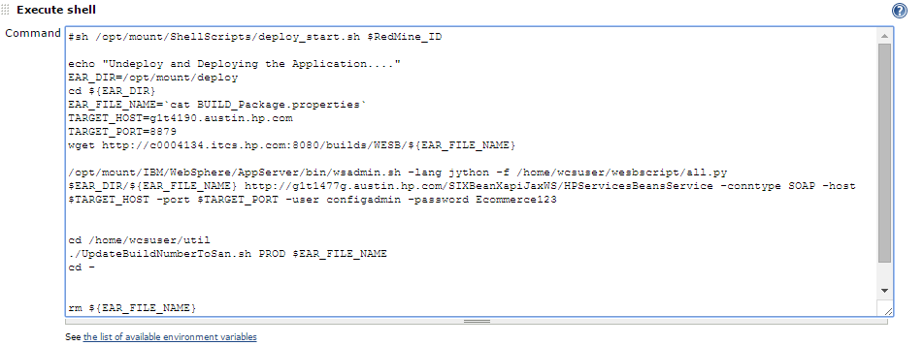

Click on Build now and view console output for the progress of WESB Deployment.

**Check : saved app, error, exception.**

#################################################################################################

1. CTO:

CONFIGURATOR BUILD AND DEPLOYMENT (for Both Stage and Live):

This need to be done in Putty box:

1. Open CTO Build box -c0004995.itcs.hp.com

2. cd /opt/apps/IBM/scripts/

3. Run the following commands

ll

cd init.sh

vi init.sh

4. For Ex: The Given CTO Build is ***Configurator_t_r46066_02Feb2015_code3.0***

Change svn branch= ***code3.0*** and svn_tag= ***Configurator_t_r46066_02Feb2015_code3.0*** in inti.sh and save.

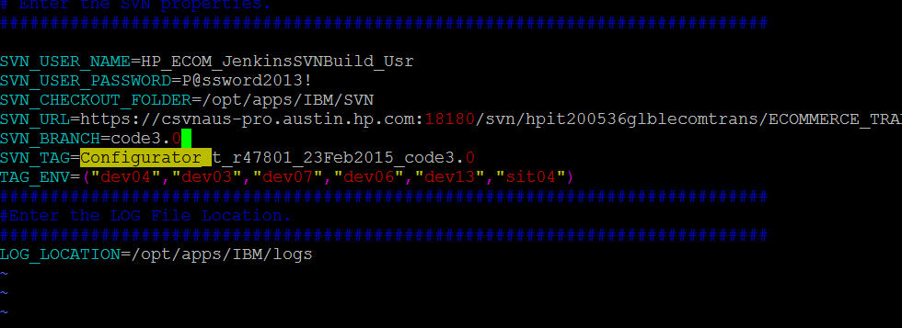

Run the below Scripts (if there is no static content move – ***check with Leads***)

5. Run the ./build Configurator.sh (Envname) under same path 🡪 Env Name is ( prd 🡪stage & lprd 🡪 Live)

Approx time taken: 20 mins

**Monitor logs:**



6. Run ./post Configurator.sh (appserver name) 🡪 CTO dmgr server (stage / Live)

7. Run ./deploy Configurator.sh (Envname)

Approx time taken: 20-30 mins

**Monitor logs:**



Run the below Scripts (if there is static content move – ***check with Leads***)

5. Run the ./build Configurator1.sh (Envname) under same path 🡪 Env Name is ( prd 🡪stage & lprd 🡪 Live)

6. Run ./post Configurator.sh (appserver name) 🡪 CTO dmgr server (stage / Live)

7. Run ./deploy Configurator1.sh (Envname)

Monitor logs –

**Build configurator (with static) -** adding: sic/swc/js/swc.min.js (deflated 75%)

**Deploy configurator (with static) -** Processes: Uninstall old applications, installing new Application, Restart of servers, Static Content.

Check .ear file in /opt/apps/IBM/WebSphere/ConfigAppServer/profiles/AppSrv01/installedApps/g4t5557Cell01

Check sterling application in CTO Console under Installed Application.



1. VM: (only stager)

This need to be done in same Putty box like CTO:

Follow the same step upto step 3:

1. Open CTO Build box -c0004995.itcs.hp.com

2. cd /opt/apps/IBM/scripts/

3. Run the following commands

ll

cd init.sh

vi init.sh

4. Here, give the VM Build name in **svn branch** and ***svn_tag*** and save it.

Run the below scripts (as like step 5 – 7 in CTO)

5. Run ./ buildSViM.sh prd

6. Run ./postBuildSViM.sh *g1t4719.austin.hp.com*

7. Run ./ deploySViM.sh prd

8. Monitor logs under /opt/apps/IBM/logs



#################################################################################################

1. OMS (Live):

Error Faced:

Deleted the entries from table YFS_OBJECT_LOCK which caused duplicate key exception after taking back up of original(YFS_OBJECT_LOCK_3rdFeb). **– faced issue in AMS 3.0 Mock MTP Hotfix – fixed by Elavarasi (replied to Lakkumanan)**

**Backup Server**: http://c0004134.itcs.hp.com:8080/oms/PROD/

**Jenkins:** <http://c0006109.itcs.hp.com:8080/jenkins/>

**OMS possess:** OMS Build+ CDT

1. **OMS :**
   1. Click on OMS Centralized Build-Prod

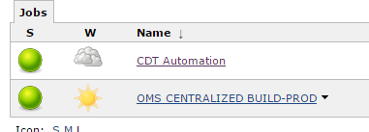

* 1. Build with parameters

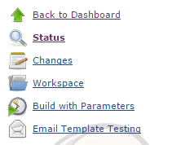

* 1. After clicking Build with parameters, you can view this page

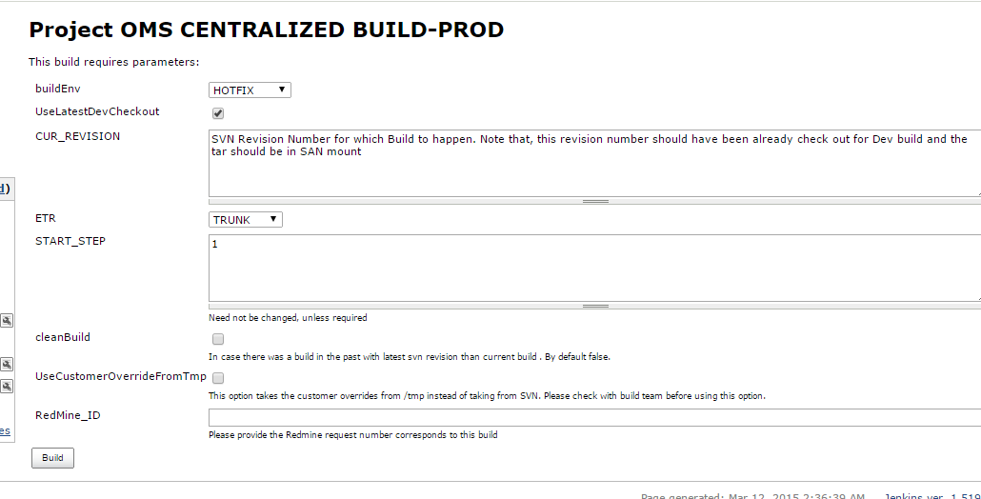

Here, Choose

* **builsEnv as PROD**

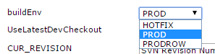

* **Unckeck Use LatestDevCheckout**



* **In Current Version give a revision number from the Build (for ex: OMS_SIT3_r45955_02FEB2015_RTRUNK_691 is a build , here r45955 is revision ID. Please give the number after ‘r’ (ie 45955) in current version):**

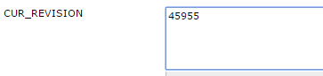

* **Choose ETR as given in Build number (OMS_SIT3_r45955_02FEB2015_RTRUNK_691)**

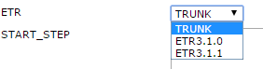

* **Start step should be always 1**
* **Uncheck the clean Build**
* **Uncheck the UseCustomerOverrideFromTop**
* **No need of redmine_ID**

**Final change looks like below:**

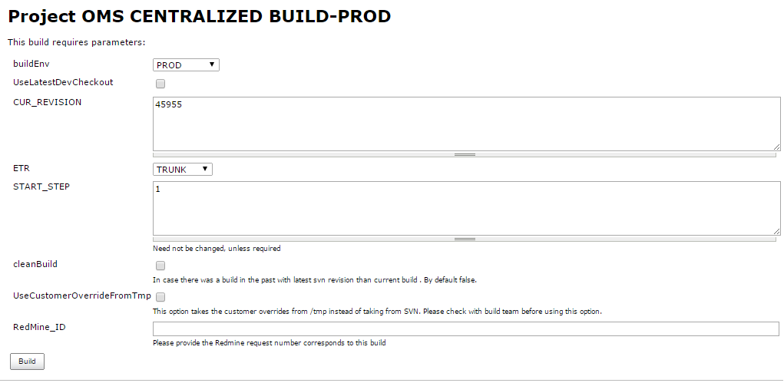

**Click on Build now and see progression in Console output (It takes 2;30-3 Hrs to complete)**

1. **CDT:**
   1. Open Jenkins and click CDT Automation

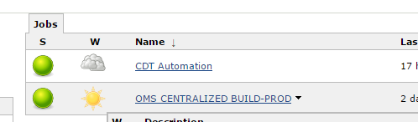

* 1. Build with Parameter:

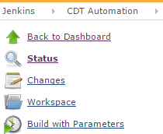

* 1. Choose environment: For ex: Prod

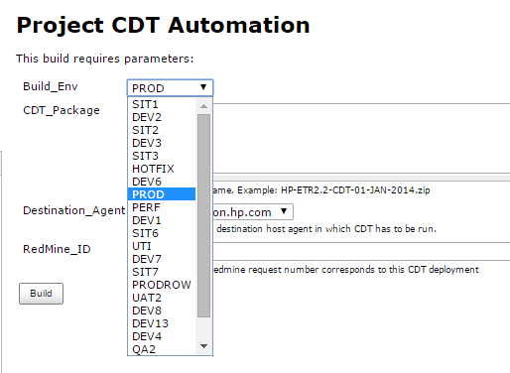

* 1. Place the CDT package name and select the destination agent as *c0007986.itcs.hp.com*

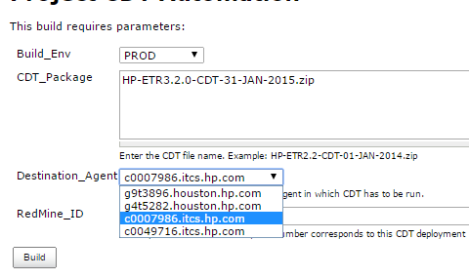

* 1. Click on Build & navigate to console output for CDT completion progress.

#################################################################################################

Step 7: Maintenance page Disable:

Change the estore and mstore values to 1 (one)



#################################################################################################

Step 8: Post-Deployment activities (if any):

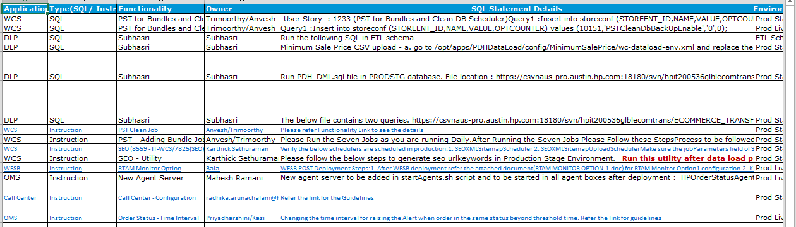

Step 9: Hotfix Patches (if any):

Please do the hotfix patches in respective environment (if any), using hotfix scripts and restart the servers (once have approval)

While doing manually, Please backup the file name using mv command and the bckp extension before the file type (.js , .sh, .css)

Ex:

For CheckoutHelper.js

Take backup as CheckoutHelper_latest_03122015(anyextension).js

Not as CheckoutHelper.js_ latest_03122015(anyextension)

Step 10: QA signoff

After all these processes, we give a site to QA signoff.

@@@@@@@@@@@@@@@@@@@@@@@@@@@@##################@@@@@@@@@@@@@@@@@@@@@@@@@@@@@@